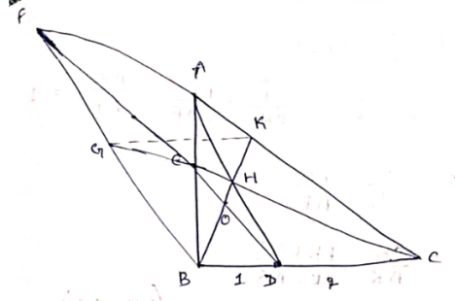
Let the point of intersection of FD, BK be 'O'
By using Menelaus theorem in $∆ FBD, ∆FDC$
abt CG abt AB
$\left|\frac{FG}{BG}.\frac{3}{2}.\frac{DE}{EA}\right|$ = 1
$\left|\frac{EF}{ED}.\frac{1}{3}.\frac{CA}{AF}\right|$ = 1
$⇒\frac{BG}{FG}=\frac{3}{2}.\frac{DE}{EF}=\frac{1}{2} \frac{AC}{AF}=\frac{1}{2} .\frac{AK+CK}{FK-AK}$ -----------------(1)
Similarly, Menelaus theorem is $∆$ADC, $∆ABD$, $∆FBA$
abt BK abt CE abt CG
$\left|\frac{AH}{HD}.\frac{1}{3}.\frac{CK}{AK}\right|$ = 1 ---------(2)
$\left|\frac{AH}{HD}.\frac{2}{3}.\frac{BE}{AE}\right|$ = 1 -------- (3)
$\left|\frac{BE}{AE}.\frac{AC}{FC}.\frac{FG}{BG}\right|$ = 1 -------- (4)
we know that $\frac{FG}{BG}= \frac{2AE}{AC}$ from (1)
by substituting in (4)
$$\frac{BE}{AE}.\frac{AC}{FC}.\frac{2AF}{AC}=1$$
$\frac{BE}{AE}=\frac{FC}{2AF}$ ------------------(5)
Substituting (5) in (3)
$$\frac{AH}{HD}.\frac{2}{3}.\frac{FC}{2AF}=1$$
$\frac{AH}{HD}=\frac{3AF}{FC}$ ----------------------(6)
$⇒$ Menelaus Theorem in $∆FDC$abt BK ; $∆FDA$abt BK
$\left|\frac{OF}{OD}.\frac{1}{3}.\frac{CK}{FK}\right|$ = 1 ---------------- (7)
$\left|\frac{OF}{OD}.\frac{DH}{AH}.\frac{AK}{FK}\right|$ = 1 --------------- (8)
Substituting (7), (6) in (8)
$\frac{OF}{OD}.\frac{FC}{3AF}.\frac{AK}{FK}$ = $\frac{3FK}{CK}.\frac{FC}{3AF}.\frac{AK}{FK}=1$
$⇒$ $\frac{CK}{AK}= \frac{FC}{AF}$
$\frac{CK}{AK}$ = $\frac{FK+CK}{FK-AK}$
CK. FK - CK.AK = AK. (FK+CK)
$AK= \frac{FK.CK}{2CK+FK}$ -------------------------(9)
Substituting 'AK' expression in (1)
$$\frac{BG}{FG}= \frac{1}{2}$$
$\frac{AK+CK}{FK-AK}$= $\frac{1}{2}\left[\frac{\frac{FK.CK}{2CK+FK}+CK}{FK-\frac{FK.CK}{2CK+FK}}\right]$
= $\frac{1}{2}\left[\frac{CK\left(2\right)(CK+FK)}{FK(CK+FK)}\right]$
$\frac{BG}{FG}=\frac{CK}{FK}$
Ms.Naga Bhavya Sree
$$\frac{FG}{FB}=\frac{FK}{FC}$$
$⇒$ $∆FGK \sim ∆FBC$
$$⇒GK ∥ BC$$
***********

